S&C June 2011 Model Answer

**NB:** With S&C papers, there are often multiple ways to answer a question and still achieve all the marks. This example shows the answers that I’d use if I was sitting the exam, sometimes with additional possible answers.

Key areas that attract marks are shown in bold where appropriate, to help you spot them, and teacher’s notes have been included. Note that where a question might ask for two examples, I’ve often given more to show some alternative answers you could consider.

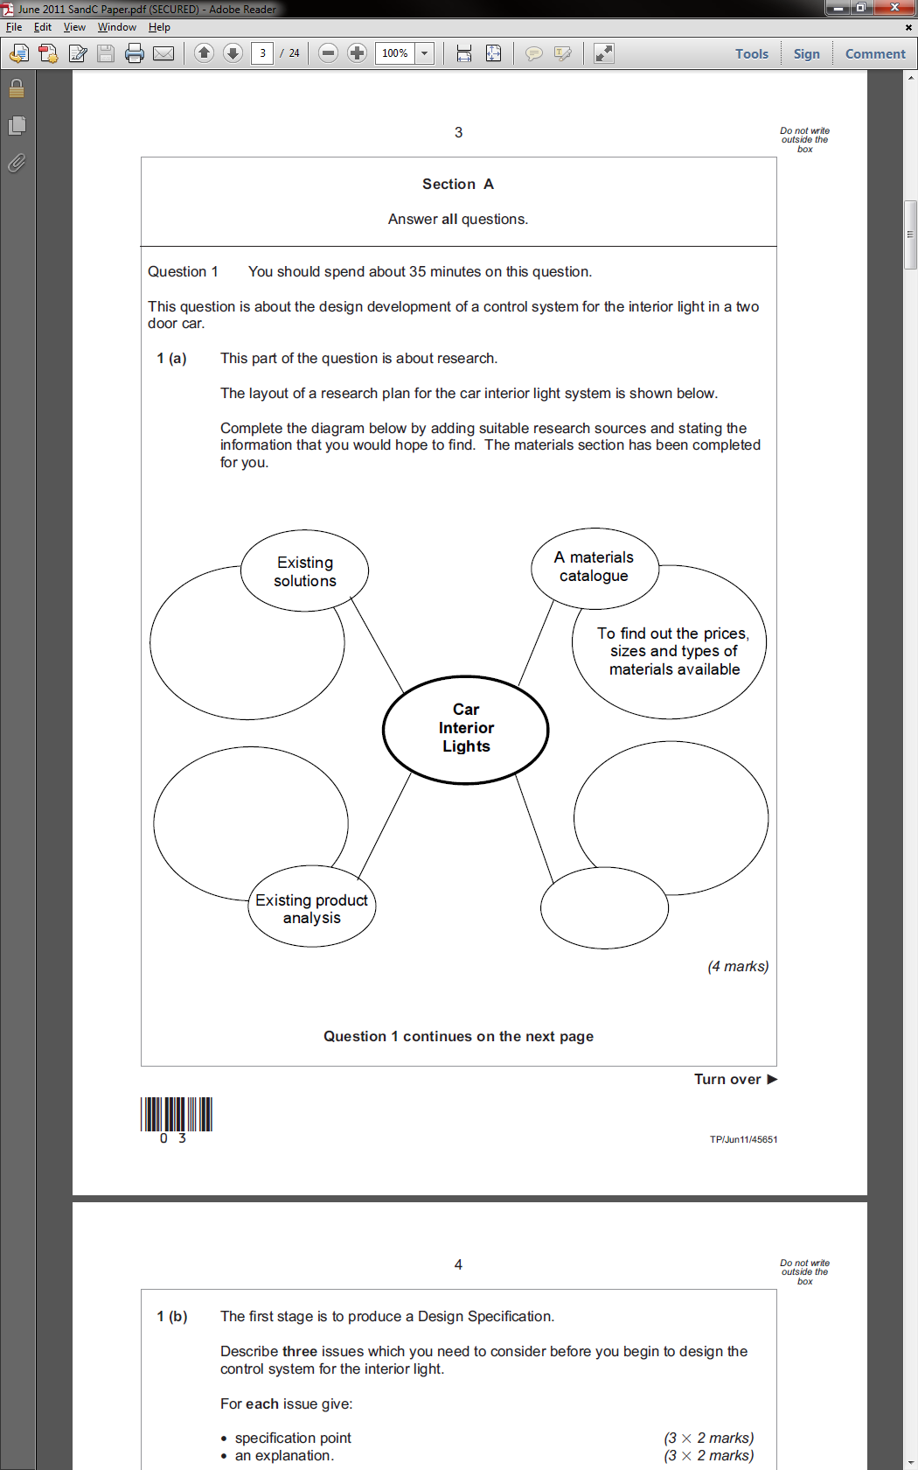

1a.

To identify their strengths & weaknesses and see how others have solved the problem.

**Teacher’s notes:** This is a standard type of diagram that the examiner likes to use. Look at other example papers for ideas on what type of response they are looking for.

Explore competitors’ sites to look at features of competing products.

Online search

Indication of dimensions, power requirements and cost.

1b. Specification points and explanations.

Point 1: Should be able to run on 12V.

Explanation: This is the voltage supplied by car batteries.

Point 2: Should use LED lights.

Explanation: Lower current draw than incandescent lamp, so less demanding on the car’s batteries, and less likely to cause a flat battery.

**Teacher’s notes:** Coming out with little factoids like, “a car battery produces 12V”, shows a good general knowledge. By stepping back a little and imagining that you were actually designing the product in the question, you should usually be able to come up with common sense answers.

Point 3: Should be no larger than 20 x 20 x 50 mm.

Explanation: It will need to fit inside car body panels.

1c. Microswitch.

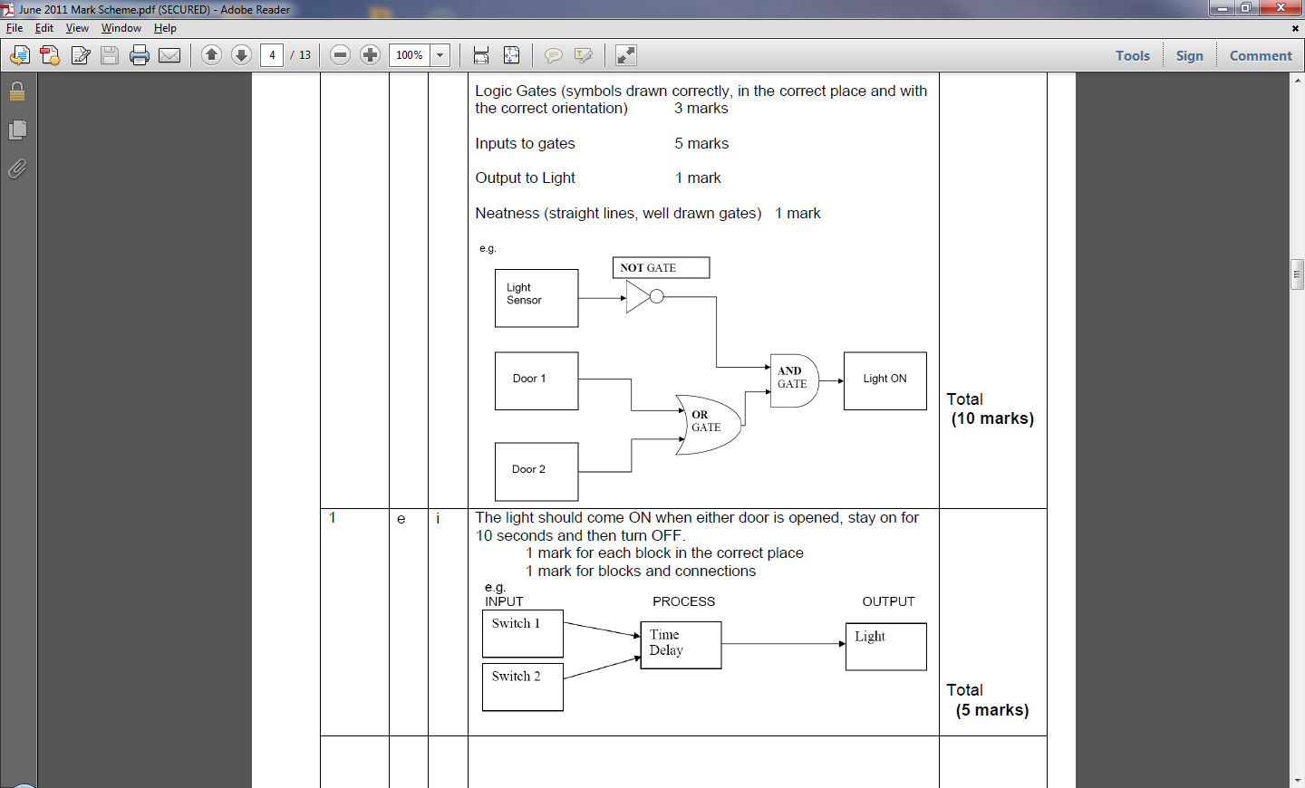1d. Logic Circuit.

**Teacher’s notes:** There are always logic questions in these exams. I like that examiner writes the name of each gate inside it in their model answer. Even if you muddle the AND and OR gates up, you *might* be able to gain some of the marks back by doing this.

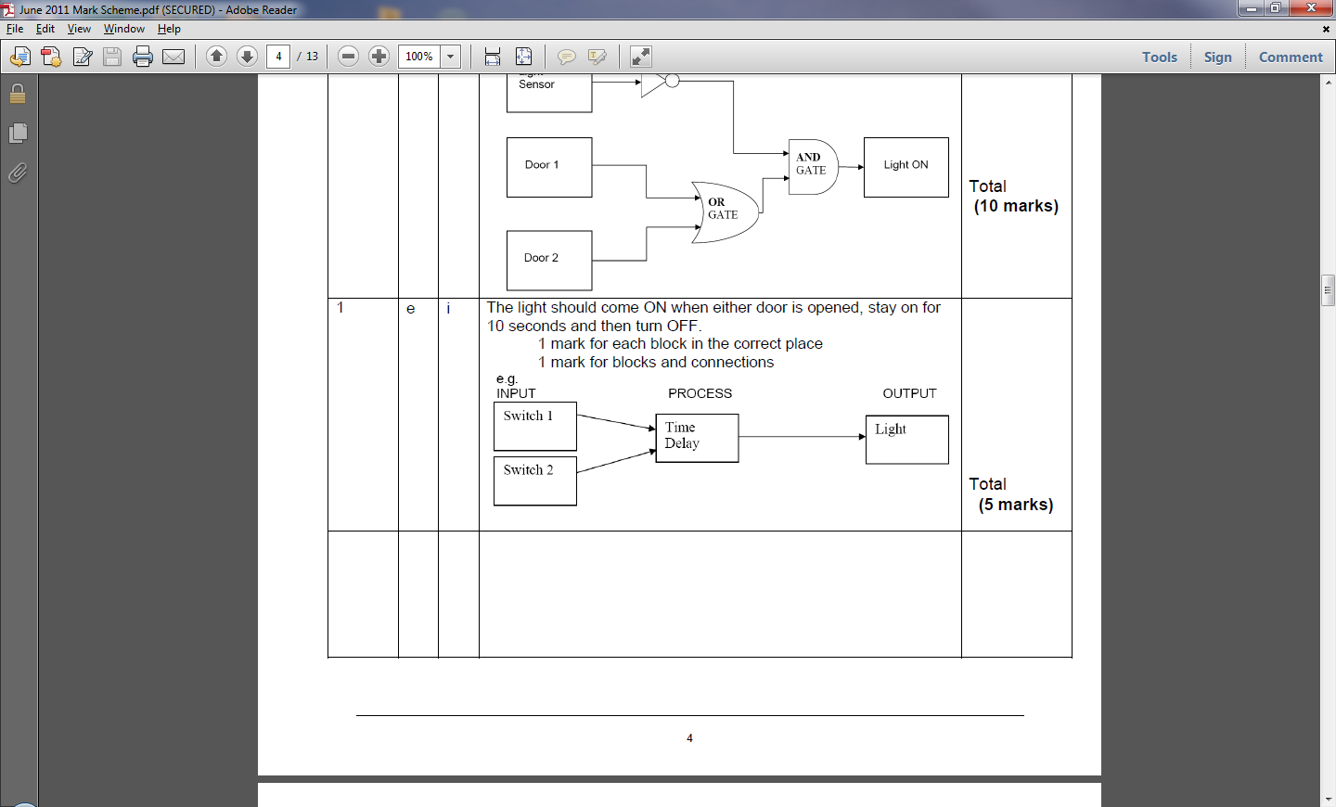

1e i. System Block Diagrams.

**Teacher’s notes:** Most exam papers have a System Block diagram question where you fill in some empty spaces. Here, you were asked to draw your own. Also unusually, there are actually 2 inputs to this system, which I imagine caught some people out back in 2011.

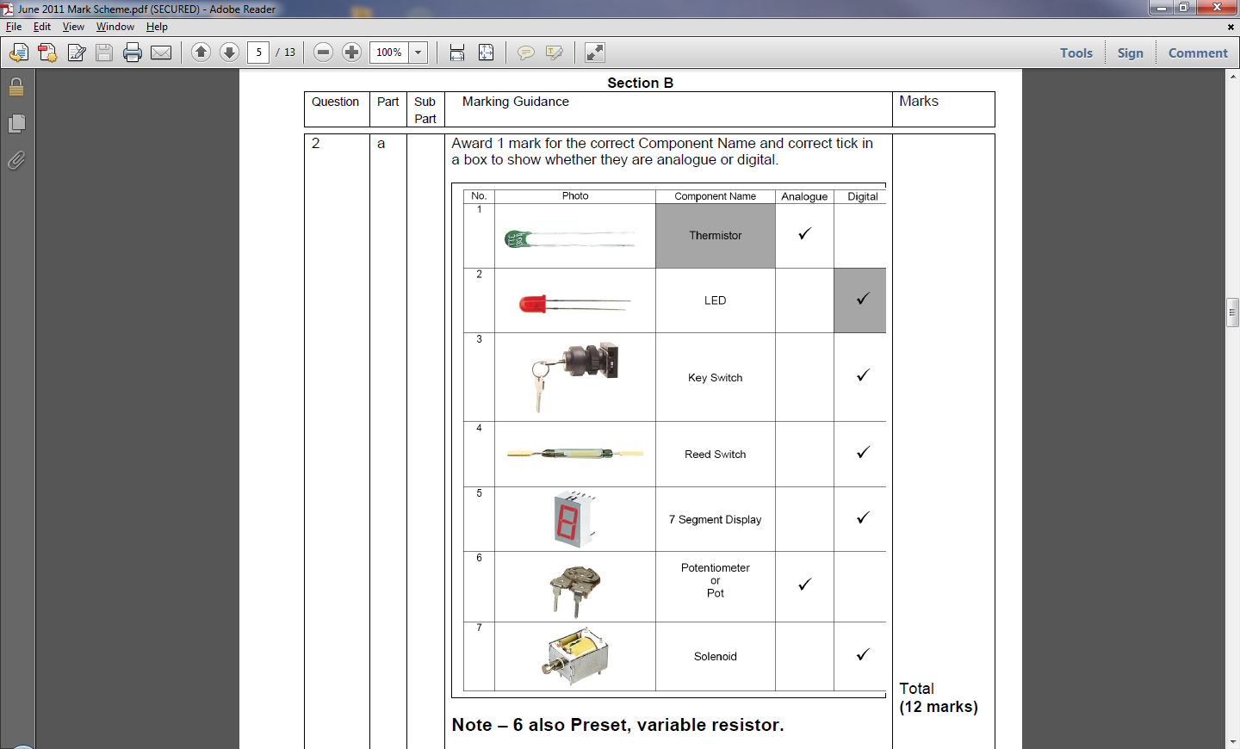

2. Digital vs. Analogue

**Teacher’s notes:** Remember that a digital component is one which can have a finite range of values. PTM switches can only be “on” or “off”, and 7-segment displays can only show the numbers 0-9, for instance.

The resistance across an LDR can sweep through any value between about 400Ω up to about 3MΩ.

2b. Digital.

**Teacher’s notes:** Some S&C questions like this are tricky to anticipate, due to the subject being so broad. At the same time, they’re not always too tricky, as this opening part of question 2 demonstrates.

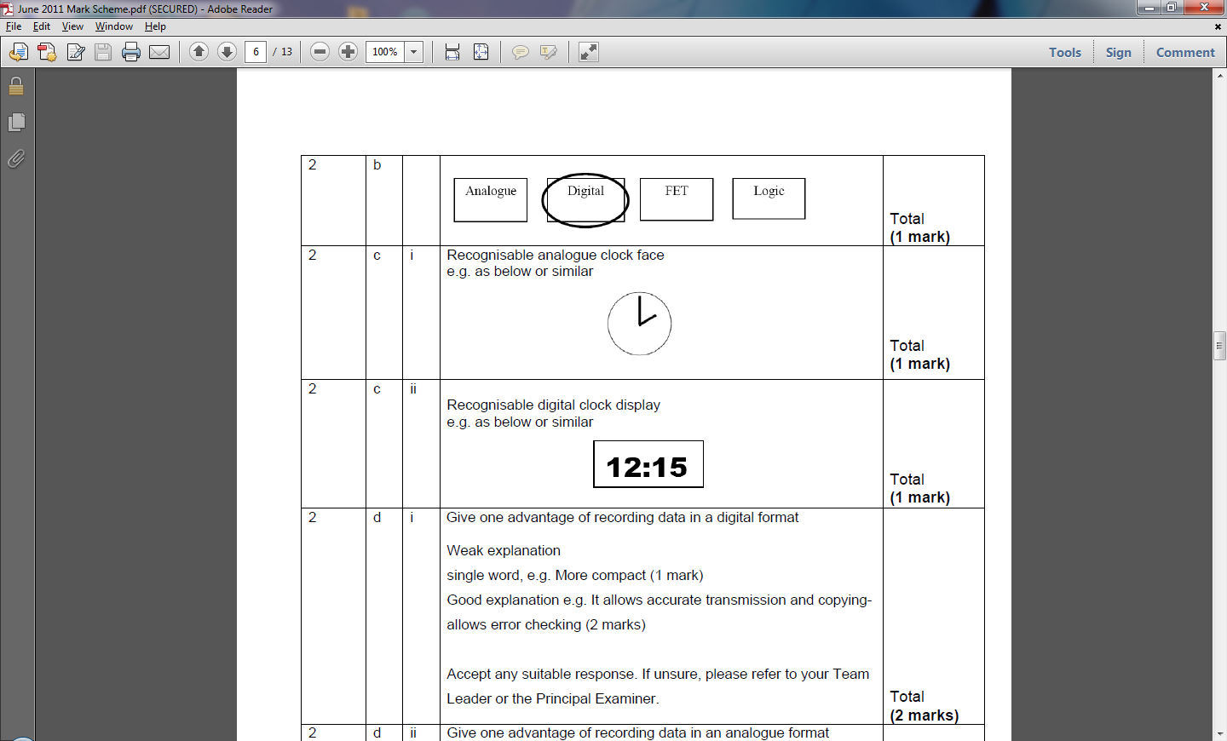

2c i. 2 c ii.

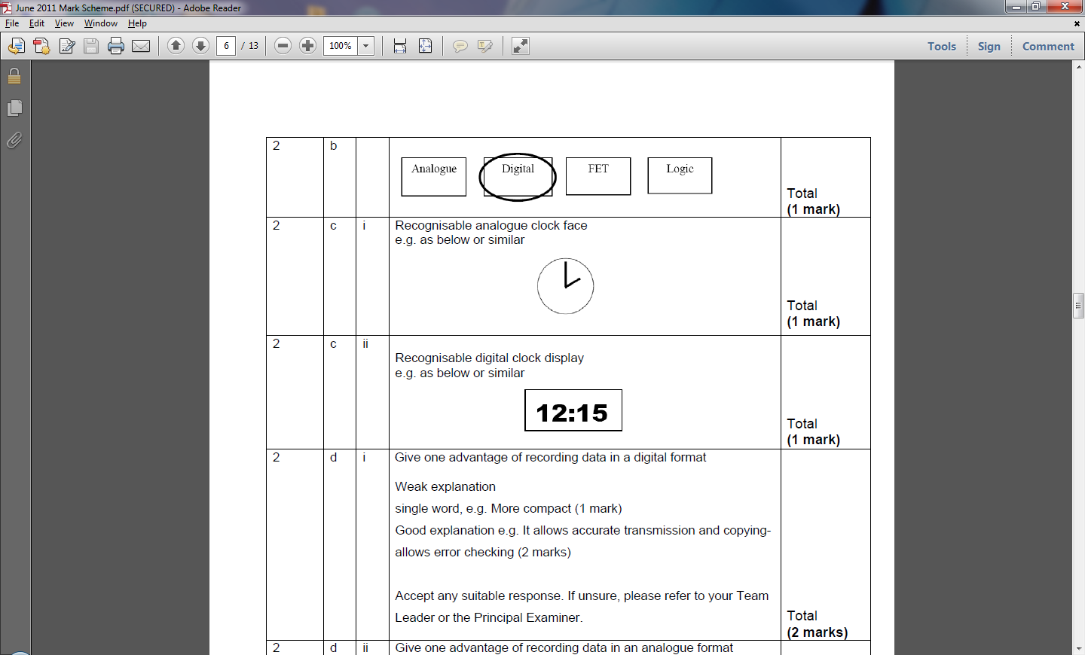

**Teacher’s notes:** This is a question I’d expect to see on a Computer Science exam paper and again, is difficult to revise for. Nonetheless, I thought about record players and the reasons DJs prefer them (better audio quality) and MP3 files (which are tiny), and created an answer based on that.

2d i. Digital data can be easily stored (e.g. on CDs or as

MP3 files), and then conveniently duplicated and

distributed.

2d ii. Because analogue data can hold any value, the

reproduction will be more accurate to the original source.

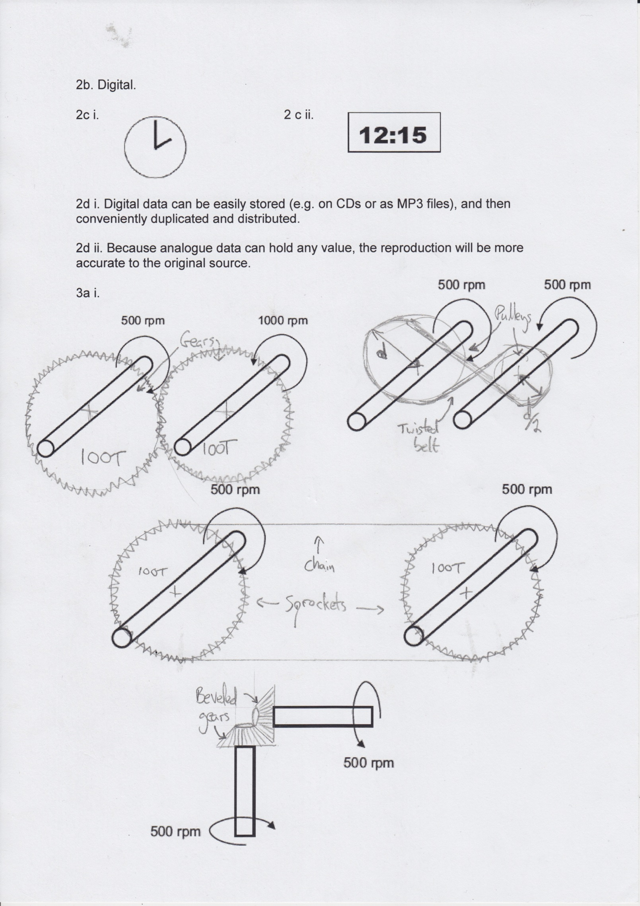

3a i.

3a ii. Gears.

**Teacher’s notes:** Drive systems and/or linkages are almost a certainty in the exams. I wrote 100T as a shorthand for “100 teeth” on my sketch, and was careful to label where I could. I debated using a twisted belt and pulley here instead, but thought I’d save that for later.

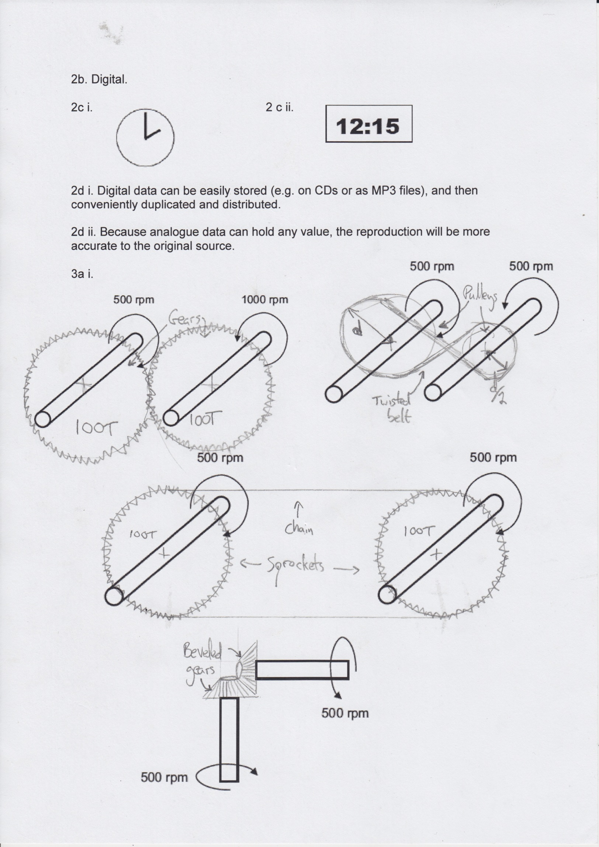3a iii.

3a iv. Sprocket and chain

**Teacher’s notes:** A sprocket is a gear which drives (or is driven by) a chain. Again, I was careful to show how many teeth I’d put on each sprocket, to make it clear that it’d have a 1:1 gear ratio.

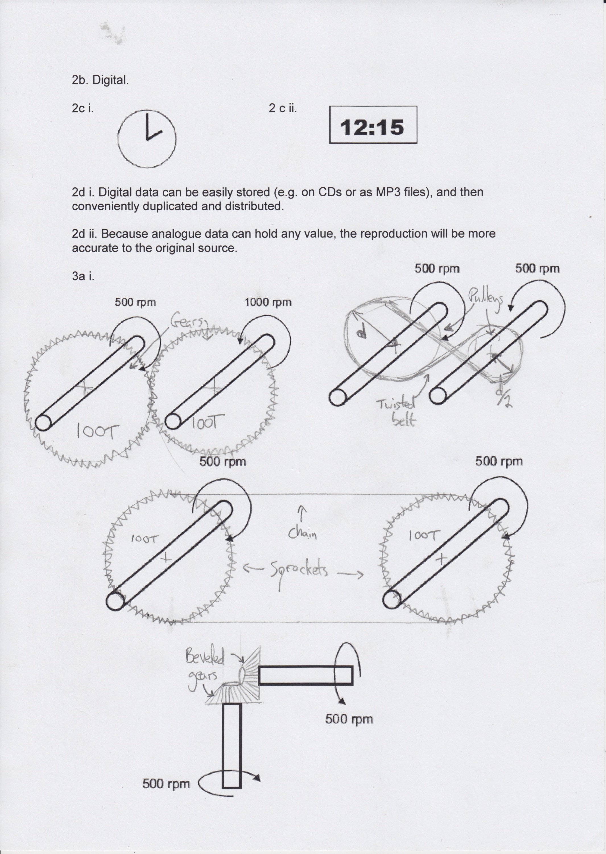3a v.

3a vi. Twisted belt on pulleys

**Teacher’s notes:** I deliberately used a variety of different solutions (although you could use gears for every one of these if you wanted to), so that I could demonstrate my knowledge to the examiner. Notice that I clearly marked the radius distance (*should have used “r” or “x” really; people will think I mixed up the terms, “diameter” and “radius”…*), and showed that my smaller, faster spinning shaft would have to be half the size.

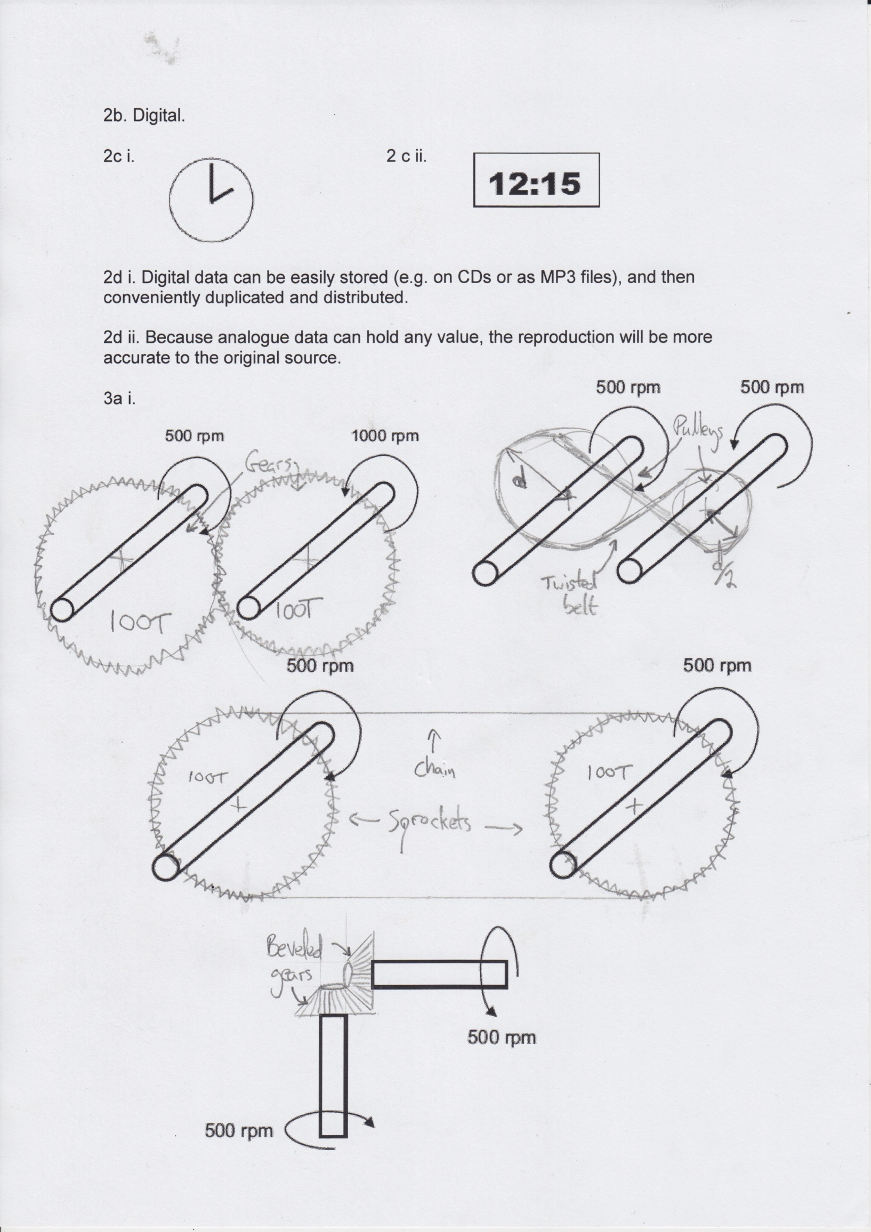3a vii.

3a viii. Bevelled gears.

**Teacher’s notes:** I could have used a worm gear with a spur gear coming off it, except I needed to maintain a 1:1 gear ratio (because it was stated in the question), and worm gears generally create a rather high ratio. I could also have used a [crown gear](http://en.wikipedia.org/wiki/Crown_gear) to achieve the same task, although these are slightly less common.

**Teacher’s notes:** I nearly started writing about brakes when I read the question initially, then I realised it was talking specifically about drive systems. Always read everything twice!

3b i. In a pulley and belt driven system, friction is (created

by keeping the belt tight) is needed to transmit force, as it

prevents the belt from slipping.

3b ii. In a gearbox, friction causes the gears to become hot

(reducing efficiency), and also to wear out over time. This is

why car gearboxes are oiled to reduce the extent to which

this happens, and prolong the life of the box.

**Teacher’s notes:** I needed a transparent material, otherwise I’d have said ABS, which is generally stronger, but doesn’t readily come in clear varieties.

4a i. Acrylic.

4a ii. Tough material, which can be easily machined to form

different shapes.

4a iii. Solenoid.

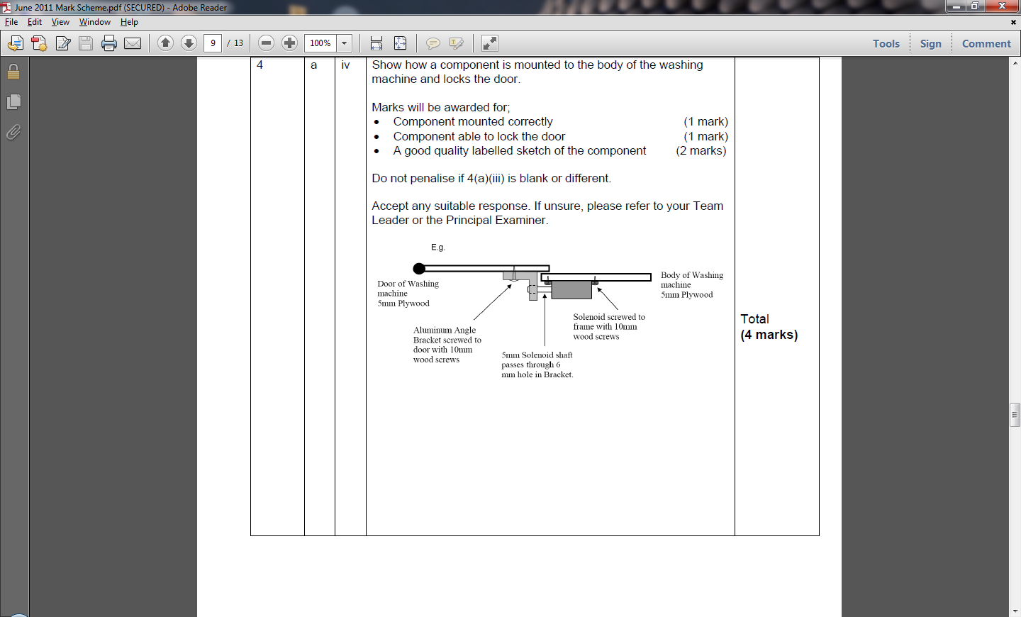4a iv.

**Teacher’s notes:** I really like the examiner’s exemplar answer. They’ve kept it simple, and having read that the model is made from a man-made board have decided to use wood screws to secure their components. The aluminium bracket with a hole in it is also a nice touch (I’d probably have said I’d make it in 3mm acrylic which I’d laser-cut, and then use the line bender to get the 90˚ bend). I’d probably also have shown a pair of wires running off the solenoid and write “to PIC”.

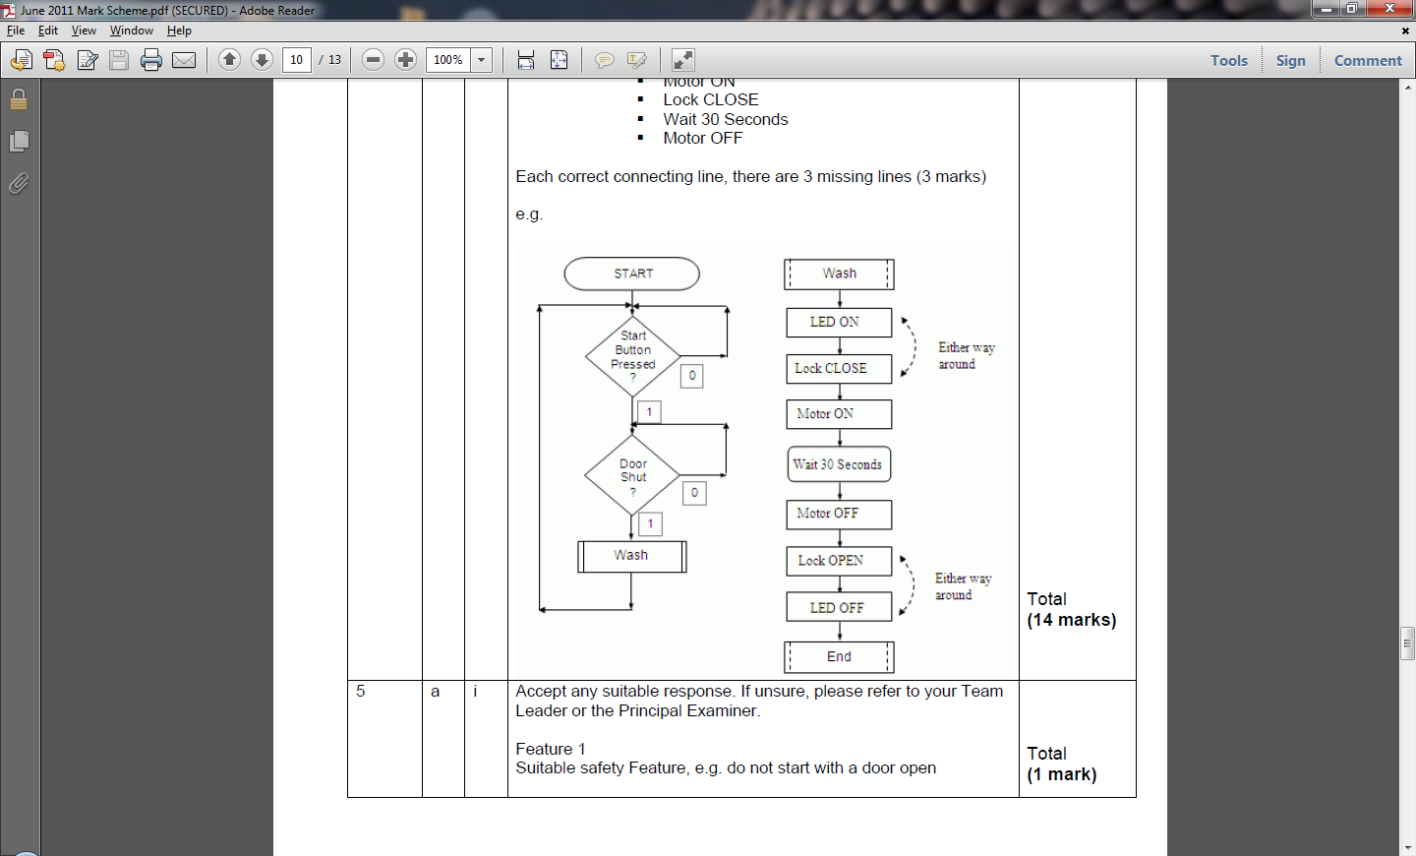4a v.

**Teacher’s notes:** Another very common feature in the exam is PIC programming. As long as you know what all the shapes are, and you read the instructions carefully, you should be able to achieve all the marks here (*and this one question is worth 12% of the marks in the paper!*)

5a. Safety features in a lift.

i. Feature 1: Doors should not open in between floors

**Teacher’s notes:** These types of questions are unpredictable, but usually come from everyday scenarios. As always, have a think and try applying some common sense to the problem at hand!

ii. Reason: To prevent injury to users

iii. Feature 2: Lift should be immobilised in the event of a

power cut

iv. Reason: To prevent the lift car falling down the shaft

5b. Maintenance on a lift

i. Task 1: Regular inspection of lift cable

ii. Explanation: To identify wear on the cable and arrange replacement.

iii. Task 2: Regular oiling of gearbox

iv. Explanation: To prevent wear of gears and potential seizing/breakdown.

5c. Safety Procedures

i. Procedure: Power to lift turned off

ii. Explanation: To prevent the motor from being energised while being serviced.

**Teacher’s notes:** You don’t have to know anything about lifts here, but instead have to be able to make some sensible guesses about how they work, and to then speculate as to what might be sensible to check, and the sorts of things that would be a good idea to do when servicing the lift (you could also say that the lift should be immobilised in the shaft to prevent anyone from being crushed by it).

6a. Sensing a person stood in a doorway.

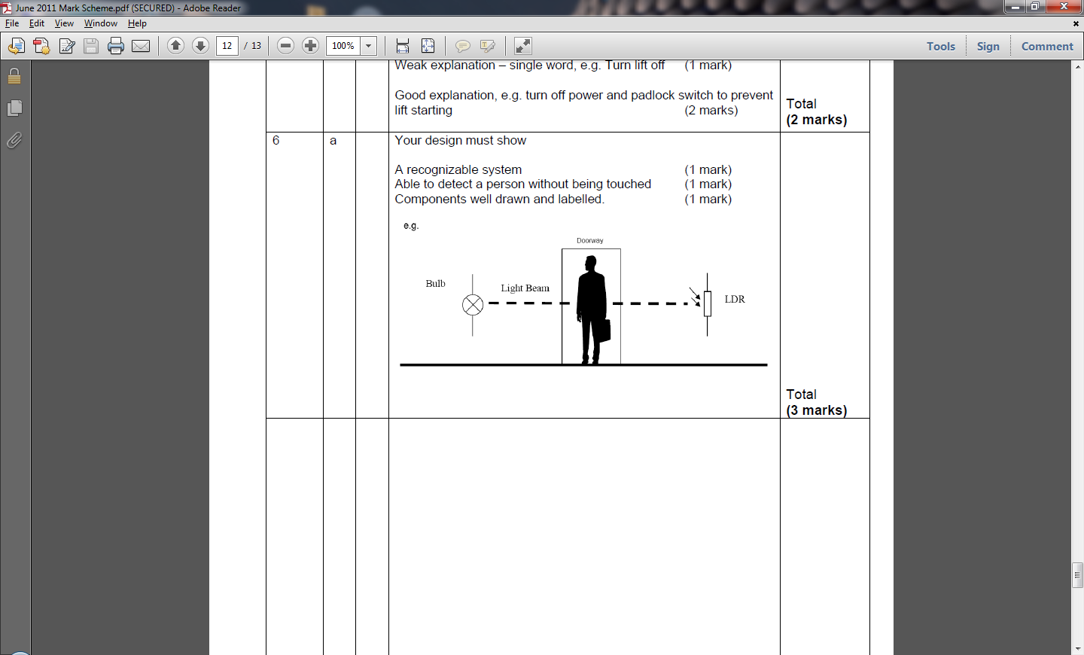

**Teacher’s notes:** Another nice, clean and straightforward solution from the mark scheme. I debated using a laser shone onto an LDR, but decided against it – a small child could trip and have it shone in their eyes, and so I did something safe. As this was only worth 3 marks (and the question didn’t ask for it), I realised I didn’t have to draw a circuit diagram and PIC program on this ocassion.

6b. The system above has a light source (I could use a laser for more accuracy, but would need to be mindful of not shining the beam in the users’ eyes) shining light across the doorway to an LDR. When a person stands in the doorway, they break the light beam. When this happens, the LDR cannot see the light any more, and so the resistance across it goes up. An analogue input on PIC chip can sense this change, and be programmed to send an output signal to control the door appropriately.

This system improves lift safety as the lift door will not close if there is a person in the doorway. A light beam is an improvement over a switch or pressure pad solution, as it senses the person without having to make contact with them and contains no mechanical parts that would be susceptible to wear out over time.

**Teacher’s notes:** Most exams have a question to test your literacy. I made sure I read the question carefully, and wrote about each of the three things it wanted me to talk about. As long as you are confident that you understand your solution to the previous part of the question, you shouldn’t have too many problems here (avoid bullet points, though!). Note the bit about how my solution was better than using a physical switch and why – this can be a nice way to try and ensure you mop up every possible mark!